Prompt:
I have attached a use case diagram of the system. Your job is to understand the functional and non-functional requirements of the system and generate high-quality manual test cases while considering the following (Accuracy, Completeness, Test Coverage, Efficiency, Quality of Test Cases, Bug Detection, Usability). The output should be arranged in a better and easier-to-understand format.
Each test case should have the following:
- Test ID (e.g T-1)
- Test Case Description
- Pre-Conditions
- Test Steps
- Test Data
- Expected Result
- Actual Result
- Status
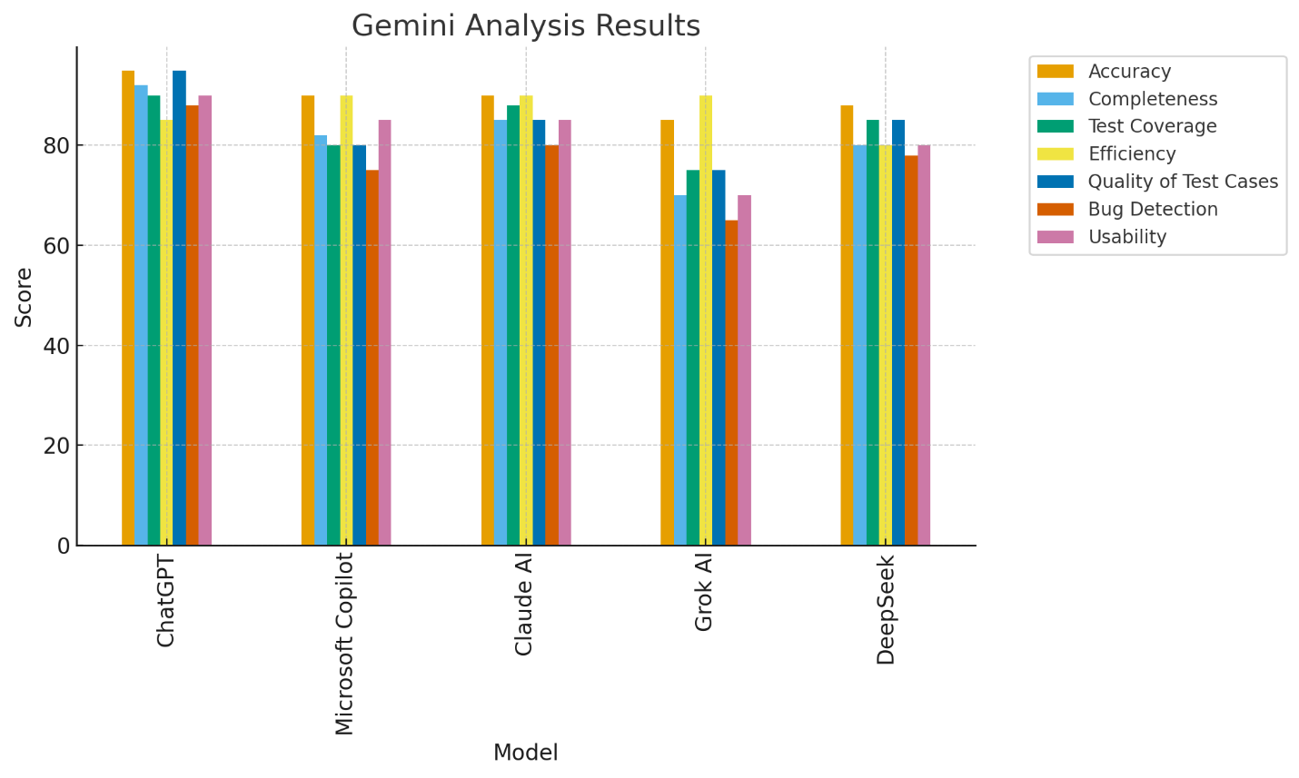
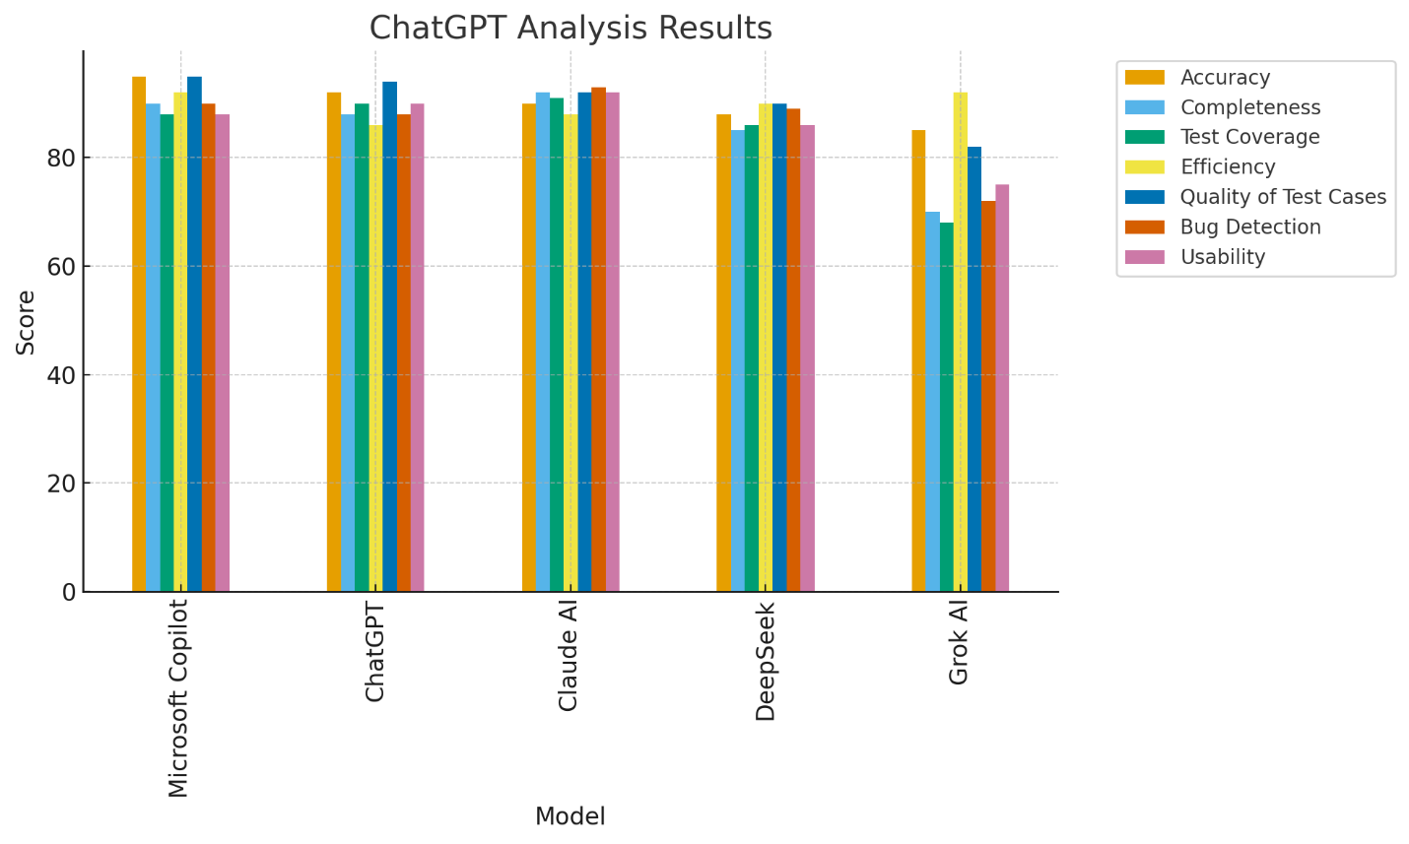

Manual Analysis:
According to the AI analysis, both Copilot and ChatGPT emerged as the top performers, while the other models ranked in the middle. However, based on the manual analysis, ChatGPT proved to be the clear winner, closely followed by Copilot. As expected, DeepSeek and Grok AI were the weakest performers.
I recommend ChatGPT’s output because it closely follows the required structure, includes both positive and negative test cases, and provides stronger overall test coverage. Copilot follows closely, but ChatGPT stands out as the final winner.

